
SVKM’s INSTITUTE OF TECHNOLOGY, DHULE
Department of Information Technology
Academic Year 2025-26

Experiment 9

Name: Bhupesh Anil Suryawanshi
Roll No.: 63
Batch: B3

Title: Medical Insurance Price Prediction using Machine Learning (Regression)

Introduction

Machine Learning is a branch of Artificial Intelligence that enables systems to automatically learn from data and improve their performance without explicit programming.
In this project, we address a regression problem, where the goal is to predict a continuous numerical value — the medical insurance cost.
This falls under the category of soft computing, as it involves data-driven learning and prediction without requiring strict mathematical modeling. Soft computing methods like regression, random forests, and gradient boosting are used to approximate nonlinear relationships between input and output variables.

Regression in Machine Learning

Regression algorithms are supervised learning methods used to model the relationship between a dependent variable (target) and one or more independent variables (features).

Types of Regression Algorithms Used

- Linear Regression:
- Establishes a straight-line relationship between input variables and the output variable.
- Simple but may not capture nonlinear dependencies.

- Ridge and Lasso Regression:
- Variants of Linear Regression that add regularization terms (L2 and L1 respectively) to prevent overfitting.
- Ridge reduces coefficient magnitude; Lasso can set some coefficients to zero.

- Support Vector Regressor (SVR):
- Finds a function that fits data within a defined margin of tolerance (ε).
- Effective for high-dimensional or small datasets.

- Decision Tree Regressor:
- Divides data into regions and fits simple models in each region.
- Easy to interpret but may overfit on training data.

- Random Forest Regressor:
- An ensemble of multiple decision trees whose results are averaged to improve accuracy and reduce overfitting.

- XGBoost (Extreme Gradient Boosting):
- An advanced boosting algorithm that builds trees sequentially to minimize errors of previous models.
- Efficient and often provides high predictive performance.

Dataset Description

The dataset used for this project is the Medical Insurance Dataset (insurance.csv).
It contains demographic and health-related information of individuals, along with their corresponding insurance charges.

Column Name | Description
age | Age of the insured person (integer)
sex | Gender (male/female)
bmi | Body Mass Index — indicator of body fat
children | Number of children/dependents covered by insurance
smoker | Whether the person is a smoker (yes/no)
region | Geographical region (northeast, northwest, southeast, southwest)
charges | The insurance cost (target variable)

Dataset Summary

- Total Records: 1338
- Missing Values: None
- Duplicates: None
- Data Type: Mix of numeric and categorical features

Methodology

The project workflow follows the typical stages of a machine learning pipeline:

1. Data Loading and Inspection
- The dataset was imported using Pandas.
- Basic checks (shape, info, null values, duplicates) ensured data quality.

2. Data Visualization and Exploration
- Various relationships were explored using Matplotlib and Seaborn:
- Age vs Charges: Older people tend to have higher medical costs.
- BMI vs Charges: Higher BMI often leads to higher charges.
- Smoker vs Charges: Smokers have drastically higher medical costs.
- Region and Children vs Charges: Minimal impact compared to smoking and age.
- A correlation heatmap was also plotted to identify which variables are most strongly related to the target (charges).

3. Data Preprocessing
- Encoding:
  - sex and smoker converted to binary (0/1).
  - region converted using one-hot encoding.
- Feature Scaling:
  - Applied StandardScaler to normalize all numerical features.
- Splitting:
  - Dataset split into 80% training and 20% testing sets using train_test_split().

4. Model Implementation
Five machine learning models were trained and tested:

Model | Description
Linear Regression | Baseline regression model
Ridge & Lasso | Regularized linear models
SVR (Linear Kernel) | Margin-based regression
Decision Tree | Rule-based non-linear regression
Random Forest | Ensemble model combining multiple decision trees
XGBoost | Sequential ensemble model (gradient boosting)

Each model was trained on the scaled training data and evaluated on both training and testing sets.

5. Model Evaluation
The following evaluation metrics were used:
- MAE (Mean Absolute Error) – average absolute difference between predicted and actual values.
- MSE (Mean Squared Error) – penalizes larger errors more heavily.
- R² Score – measures how well the model explains variation in target values.

6. Hyperparameter Tuning
- GridSearchCV was applied on Random Forest to optimize parameters like:
- n_estimators, max_depth, min_samples_split, min_samples_leaf
- Best parameters were selected automatically based on cross-validation accuracy (R²).

Results and Analysis

Model | Train R² | Test R²
Linear Regression | 0.75 | 0.73
Ridge Regression | 0.75 | 0.73
Lasso Regression | 0.73 | 0.71
SVR | 0.76 | 0.74
Random Forest | 0.99 | 0.90
Decision Tree | 0.96 | 0.85
XGBoost | 0.88 | 0.84

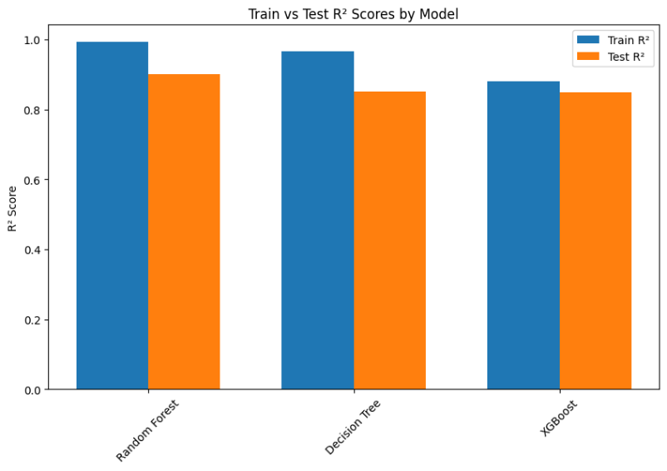
Observation:
- Random Forest outperformed all other models with an R² of 0.90 on test data.
- Smoking habit, age, and BMI were found to be the most influential features.

Conclusion

The Medical Insurance Price Prediction project successfully demonstrates the use of soft computing techniques (machine learning regression) to predict real-world continuous values.
Among all models, the Random Forest Regressor achieved the best performance with high accuracy and generalization.
This project highlights how machine learning can effectively model nonlinear relationships in healthcare data to estimate insurance costs, supporting better pricing and decision-making processes.

